Ruby Bridges statue unveiled
Posted on November 14, 2014 7:03 PM | Updated November 14, 2014 7:03 PM
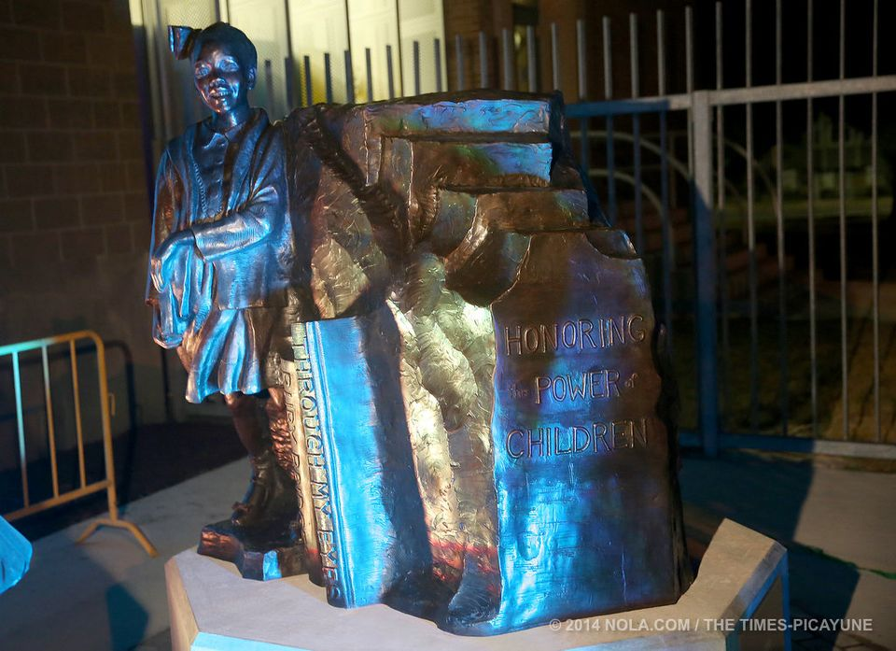
1 / 11
Michael DeMocker
Ruby Bridges statue unveiling
The statue of Ruby Bridges unveiled for the 54th anniversary of her integrating the William Frantz School.
Photographed on Friday, November 14, 2014. (Michael DeMocker, Nola.com / The Times-Picayune) Buy Image
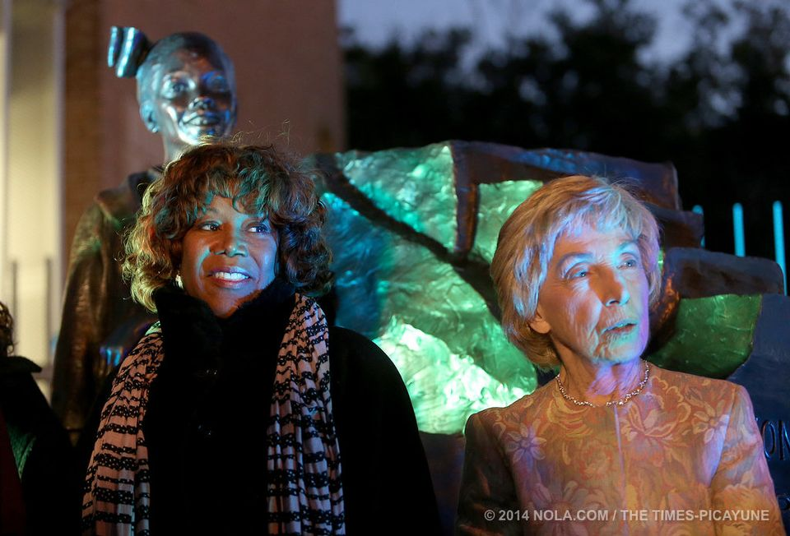
2 / 11
Michael DeMocker
Ruby Bridges statue unveiling
Ruby Bridges and her former teacher Barbara Henry pose after the unveiling of a statue of Bridges for the 54th anniversary of her integrating the school.
Photographed on Friday, November 14, 2014. (Michael DeMocker, Nola.com / The Times-Picayune) Buy Image
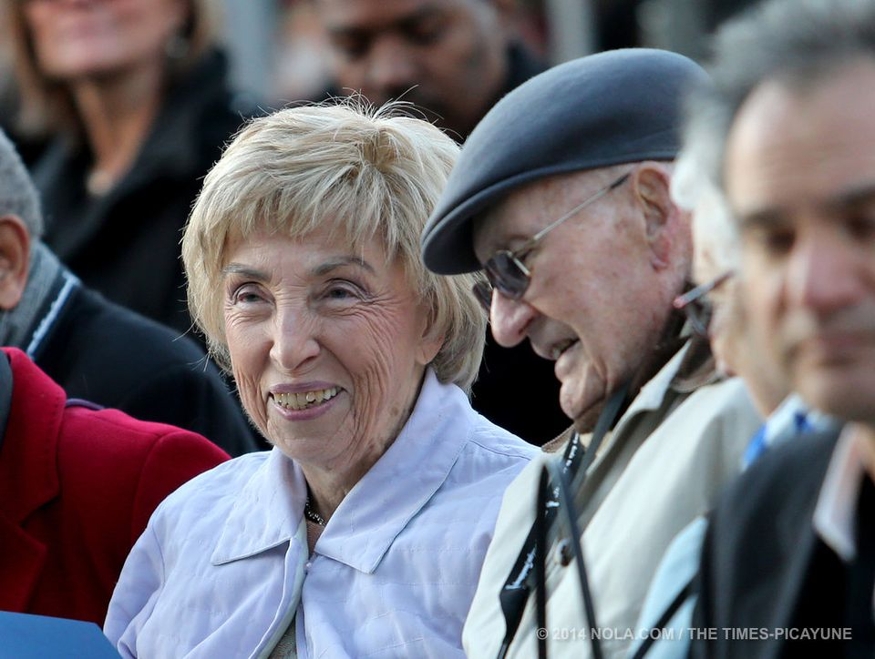
3 / 11
Michael DeMocker
Ruby Bridges statue unveiling
Ruby Bridges' former teacher Barbara Henry and U.S. Marshal Charlie Burks, who escorted Bridges into school, talk during a ceremony at the
former William Frantz School for the unveiling of a statue of Bridges on the 54th anniversary of her integrating the school.
Photographed on Friday, November 14, 2014. (Michael DeMocker, Nola.com / The Times-Picayune) Buy Image
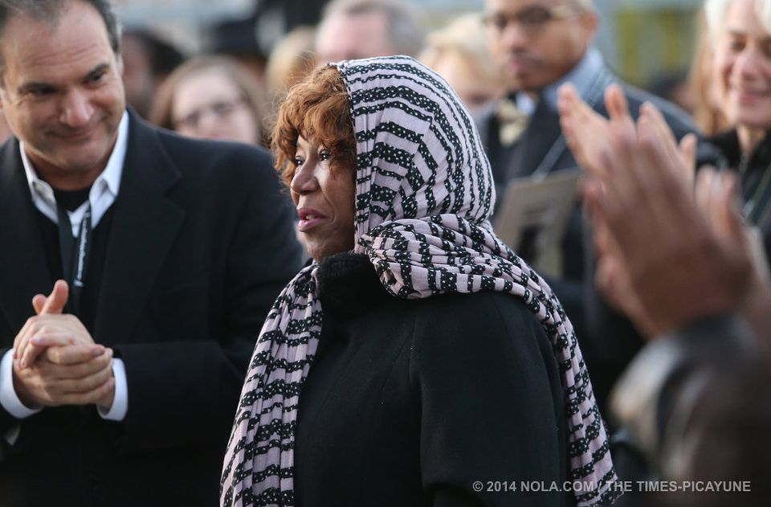
4 / 11
Michael DeMocker
Ruby Bridges statue unveiling
Ruby Bridges is applauded as she is introduced during a ceremony at the former William Frantz School for the unveiling of a statue of Bridges
on the 54th anniversary of her integrating the school.
Photographed on Friday, November 14, 2014. (Michael DeMocker, Nola.com / The Times-Picayune) Buy Image
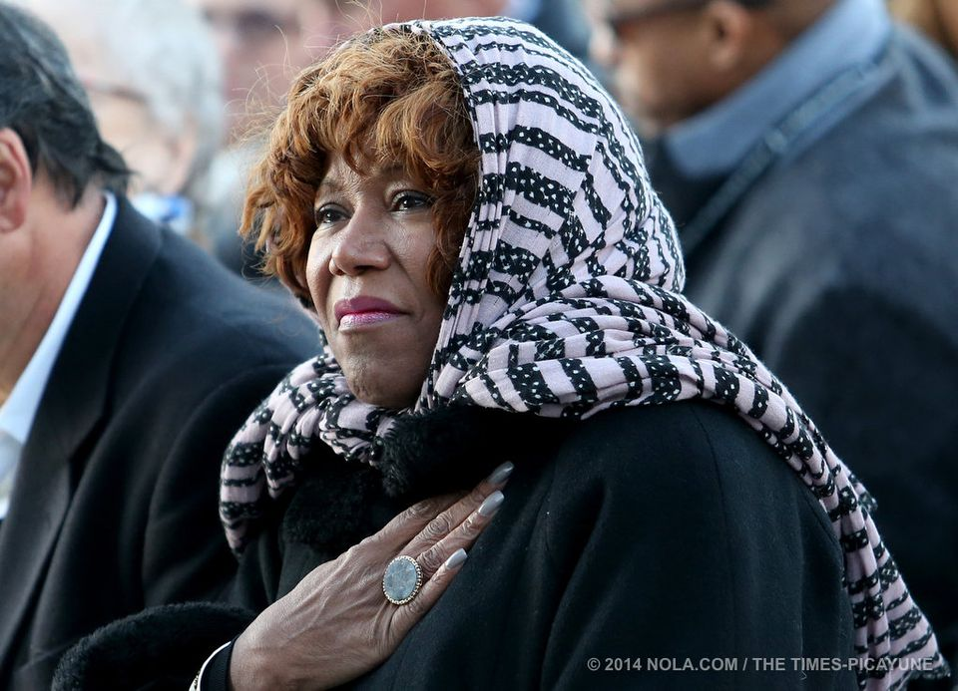
5 / 11
Michael DeMocker
Ruby Bridges statue unveiling
Ruby Bridges listens during a ceremony at the former William Frantz School for the unveiling of a statue of Bridges
on the 54th anniversary of her integrating the school.
Photographed on Friday, November 14, 2014. (Michael DeMocker, Nola.com / The Times-Picayune) Buy Image
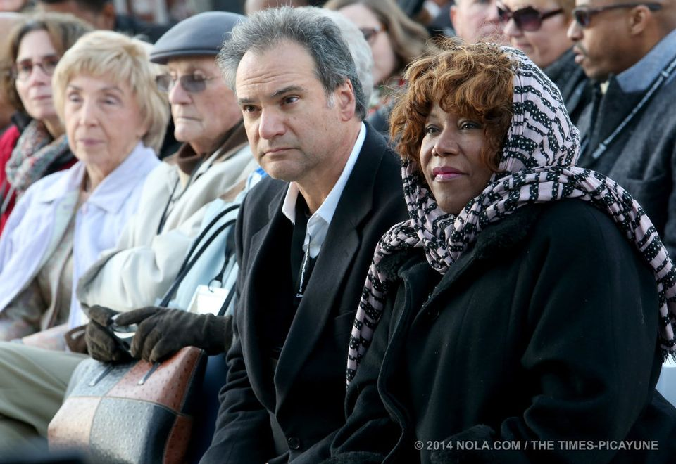
6 / 11
Michael DeMocker
Ruby Bridges statue unveiling
Ruby Bridges (right) is joined by (from left) her former teacher Barbara Henry, U.S. Marshal Charlie Burks and sculptor Mario Chiodo during a ceremony
at the former William Frantz School for the unveiling of a statue of Bridges on the 54th anniversary of her integrating the school.
Photographed on Friday, November 14, 2014. (Michael DeMocker, Nola.com / The Times-Picayune) Buy Image
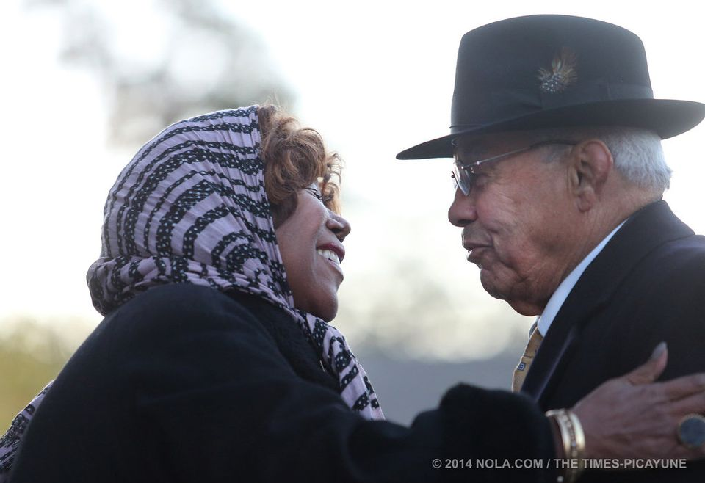
7 / 11
Michael DeMocker
Ruby Bridges statue unveiling
Ruby Bridges hugs Xavier president Dr. Norman Francis after he introduces her during a ceremony at the former William Frantz School
or the unveiling of a statue of Bridges on the 54th anniversary of her integrating the school.
Photographed on Friday, November 14, 2014. (Michael DeMocker, Nola.com / The Times-Picayune) Buy Image
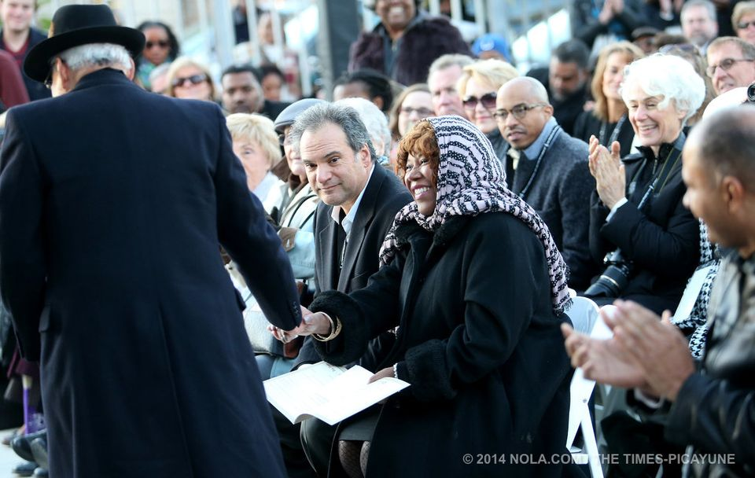
8 / 11
Michael DeMocker
Ruby Bridges statue unveiling
Ruby Bridges shakes the hand of Xavier president Dr. Norman Francis as he prepares to introduce her during a ceremony at the former William Frantz School
for the unveiling of a statue of Bridges on the 54th anniversary of her integrating the school.
Photographed on Friday, November 14, 2014. (Michael DeMocker, Nola.com / The Times-Picayune) Buy Image
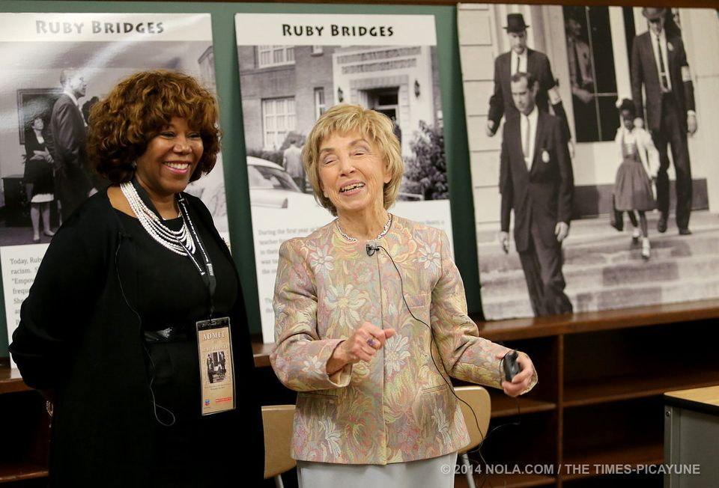
9 / 11
Michael DeMocker
Ruby Bridges statue unveiling
Ruby Bridges and her former teacher Barbara Henry share a laugh inside the classroom at the William Frantz School
where they once held class by themselves in 1960. The pair reunited for the unveiling of a statue of Bridges for the 54th anniversary of her integrating the school
hotographed on Friday, November 14, 2014. (Michael DeMocker, Nola.com / The Times-Picayune) Buy Image
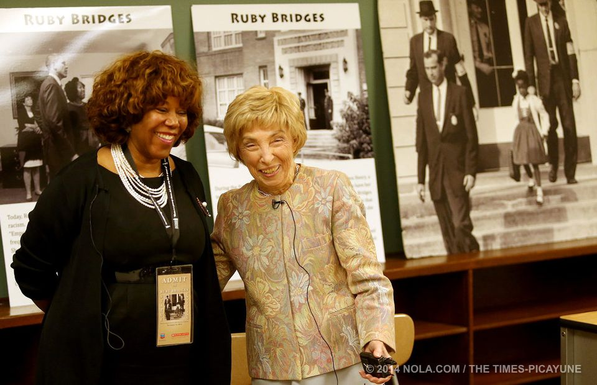
10 / 11
Michael DeMocker
Ruby Bridges statue unveiling
Ruby Bridges and her former teacher Barbara Henry share a laugh inside the classroom at the William Frantz School
where they once held class by themselves in 1960. The pair reunited for the unveiling of a statue of Bridges for the
54th anniversary of her integrating the school.
Photographed on Friday, November 14, 2014. (Michael DeMocker, Nola.com / The Times-Picayune) Buy Image
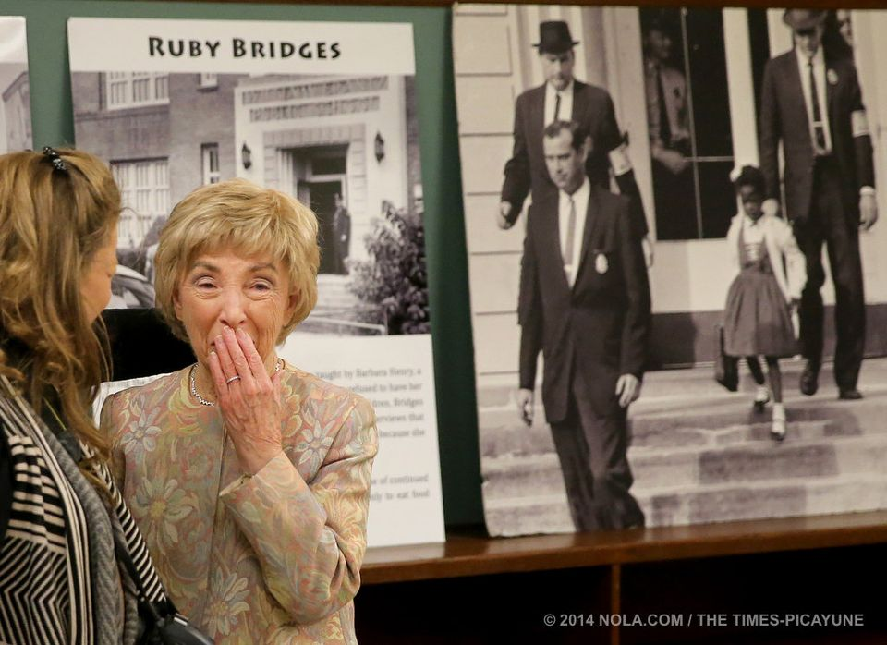
11 / 11
Michael DeMocker
Ruby Bridges statue unveiling
Ruby Bridges' former teacher Barbara Henry is overcome with emotion as she returns to the classroom at the William Frantz School
where they once held class by themselves in 1960. The pair reunited for the unveiling of a statue of Bridges for the 54th anniversary of her integrating the school.
Photographed on Friday, November 14, 2014. (Michael DeMocker, Nola.com / The Times-Picayune) Buy Image
…More

New Ruby Bridges statue inspires students, community

11
Gallery: Ruby Bridges statue unveiled

Print Email
By Danielle Dreilinger, NOLA.com | The Times-Picayune
Email the author | Follow on Twitter
on November 14, 2014 at 9:12 PM, updated November 14, 2014 at 9:54 PM

Civil Rights News
- If Martin Luther King were here, we'd probably be no less divided
- National WWII Museum to host 'Electronic Field Trip' on black experiences in the war
- Wyatt T. Walker was the matador to Birmingham's Bull Connor
- Landry praises new office created to protect doctors' rights to refuse service based on moral, religious beliefs
- MLK day marked by protests, pledges to fight racism
Fifty-four years ago, Ruby Bridges walked up the six stairs into William Frantz Elementary in the 9th Ward, past furious protesters, to integrate the New Orleans public school. Now, she will always be walking to those steps - in a bronze statue unveiled in the courtyard Friday evening.
But so very unlike Nov. 14, 1960, the crowd included black and white faces, and all those present were celebrating together.
"What a difference to be here with a welcoming group," said Barbara Henry, the teacher who spent the year alone with Bridges while the white students learned, ate and played without them.
The unveiling reunited, for the first time, four principal players: Bridges, her mother Lucille, Henry and Charlie Burks, the last survivor of the four U.S. marshals who escorted Bridges to and from school each day and even to and from the restroom.
Attendees and speakers included former Mayor Moon Landrieu, Sheriff Marlin Gusman, Baton Rouge federal court Chief Justice Brian Jackson, Ira Thomas and Cynthia Cade of the Orleans Parish School Board and Amanda Shaw playing "God Bless America" on the fiddle.
Frantz has been renovated and expanded, preserving Bridges' classroom, and reopened last year as the home of Akili Academy charter school. Standing in the courtyard between the old and new buildings, Principal Allison Lowe drew a line from 1960 to 2014. Bridges "opened a door for generations of students to enter," she said. "We know that every student in New Orleans deserves a future of limitless possibility. It is our job to create that."
Despite the frigid weather, people stood on the sidewalk outside the invitation-only event and held up their phones to record Bridges' remarks. Xavier University President Norman Francis called Bridges "an icon of this country."
"I try very, very hard to be humble, to remember it's really not about me," said Bridges, who speaks about civil rights around the country. "It's about the message." The statue "is about preserving history. About giving kids something to look up to."
Several black girls attending the event said they absolutely did look up to her.
Gabbi Polite, a fifth-grader at the Isidore Newman School, dressed up as Bridges and interviewed her for a class project. "If she didn't do that, I wouldn't be at my school now," she said.
In Polite's imagination, "I can feel how hard it must've been - especially for her to just be in one classroom ... (with people) yelling at you wherever you go."
Without Bridges, "black children would not be able to get as much of an education as they're supposed to," said Akili seventh-grader Kareian Johnson. She walks by the classroom all the time and "it touches me because I think about what she went through."
Johnson saw the positive side to Bridges' isolation that first year: "She got that one-on-one attention," she said pragmatically.
She did indeed. The bond between teacher and student became so strong that they remembered their time together as joyous -- a bubble protected from the anger and hatred outside.
"I think we were very lucky," Henry said.
Even though when Bridges was finally allowed to join other children at recess after months of Henry pushing for it, a boy told her he couldn't play because of her race. "That was the day I actually realized what was going on," Henry said upstairs on the second floor.
Entering the restored classroom for the first time, Henry became choked up. "I'm sorry," she whispered, touching a desk. "But it was happy times then. I shouldn't cry. We didn't cry then."
Henry evoked a luminous loneliness: sitting side-by-side with Ruby working on reading; the teachers refusing to talk to her; the marshal escorting her student in.
At the doorway, Bridges took "tiny steps ... She never was in a hurry because we couldn't start without her," Henry said.
From all white, Frantz has become almost all black. Bridges recently cited that to the Associated Press as partial evidence of a "new segregation."
Johnson, the Akili seventh-grader, acknowledged the demographics of her school but didn't think that was significant. She saw pure progress.
"People don't still do racism anymore," Johnson said. All over New Orleans, "you see black kids playing with white kids. And it's because of Ruby."
See archival photos of Ruby Bridges.

Web site No longer?
https://www.cbsnews.com/news/rockwell-and-ruby/
https://www.cbsnews.com/news/ruby-bridges-rockwell-muse-goes-back-to-school/

good video:
https://www.nrm.org/2014/09/happy_birthday_ruby/

Please send letters to:
Ruby Bridges
P.O. Box 870248
New Orleans, LA 70187

