CHM 1020 B-12 Section 5064 F2F Contract
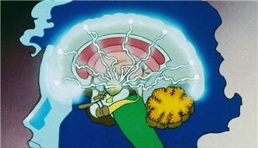
I understand this is a face-to-face 12 week class and not a 3 hour per week face-to-face 15 week section.
I understand that this B-12 F2F class is accelerated versus a normal 15 week course. A face-to-face three credit college course meets for 2250 minutes of instruction. This class meets only 1870 minutes during the course. The additional 280+ normal minutes must be used for online lecturing. Only key concepts will be covered during lecture activities and there will 10 in-class 30 minute in-class closed book testing 10 of the 12 weeks.
In high school the equivalent class has 9000 minutes of in-class instruction. In college a student is expected to study two hours (120 minutes) for each hour in class.
I understand that the Professor’s roll is to manage my learning and that I have enough time every week to study 7+ hours per week to succeed in this course in addition to class time.
I understand that many of the lectures of the chemistry content will require me to watch many short videos by the textbook author on a specific objective in each chapter section (up to 180) in addition to attending the full 3.0 hours instructor lectures/class activities. These videos are found on the external web site for this course
http://fscj.me/chm1020.html
and in Blackboard Course Content
I understand that up to50- 75% (usually around 60%) of my grade will be earned by completing online multiple-choice testing in a timely fashion; 15-30% of my grade will be an in-class testing and 10-15% online (non-proctored) midterm, end term, and vocabulary final exams; plus 10-15% projects/activities/homework.
I have read each of the above statement and agree to the F2F terms of this class. My electronic signature is below:
Print Name: _____________________________________________
Signed:_______________________________________Date:_______________________
Email Address:_____________________________________________________
Phone Number: ________________________________

