CHM 1020 A-15 Section 5056 Face-to-Face Contract
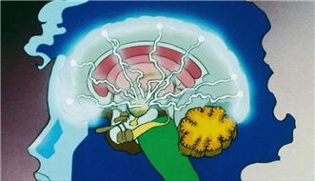
I understand this is a regular 15 week face-to-face section.
I understand that this A-15 Regular class meets a normal 15 week course. A face-to-face three credit course meets for 2250 minutes of instruction. This class meets ~2250 minutes per week for 15 week term for class activities including in-class testing.
I understand that the Professor’s roll is to manage my learning and also explain key topics of each chapter. However, there is not enough time to thoroughly explain the entire chemistry content (In high school a student has 9000 minutes for the equivalent course)
The normal formula for colleges and universities for every 3 credit course, a student need 6 hour per week outside class time for study. I have enough time every week to study 6 these hours per week to succeed in this course in addition to class time.
I understand that a many of the lectures of the chemistry content will require me to watch many short videos by the textbook author on a specific objectives each chapter (up to 180) instead of attending the full three hours instructor lectures/class activities. These videos are found on the external web site for this course and in Blackboard Course Content
I understand that up to 50-60% (usually 50%) of my grade will be earned by completing online multiple-choice testing in a timely fashion; 15-30% of my grade will be an in-class testing and 10-20% online (non-proctored) midterm, end term, and vocabulary final exams; plus 10-20% projects/activities/homework.
I have read each of the above statement and agree to the fully online terms of this class. My electronic signature is below:

Signed:_______________________________________Date:_______________________
Email Address:_____________________________________________________
Phone Number: ________________________________

