CHM 1020 A-15 Section 5056 Hybrid Contract
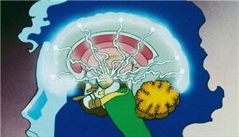
I understand this is a hybrid 15 week class and not a 3 hour per week face-to-face section.
I understand that this A-15 Hybrid class meets only one half the time versus a normal 15 week course. A face-to-face three credit course meets for 2250 minutes of instruction. This class meets only 75 minutes per week for 15 weeks, which then is only 1125 minutes of class activities including in-class testing.
I understand that the Professor’s roll is to manage my learning and that I have enough time every week to study 7.5 hours per week to succeed in this course in addition to class time.
I understand that a majority of the lectures of the chemistry content will require me to watch many short videos by the textbook author on a specific objectives each chapter (up to 180) instead of attending the full three hours instructor lectures/class activities. These videos are found on the external web site for this course and in Blackboard Course Content
I understand that up to 75% (usually 60%) of my grade will be earned by completing online multiple-choice testing in a timely fashion; 12.5-20.0% of my grade will be an inclass testing and 10-15% online (non-proctored) midterm end term, and vocabulary final exams; plus 9-155% projects/activities/homework.
I have read each of the above statement and agree to the fully online terms of this class. My electronic signature is below:
Print Name: __________________________________

Signed:_______________________________________Date:_______________________
Email Address:_____________________________________________________
Phone Number: ________________________________

