CHM 1020 B-12 Section 1196 Online Contract
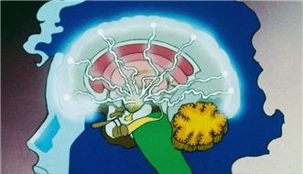
I understand this is a fully online class and not a 3-4 hour per week face-to-face B-12 section.
I understand that this B-12 class is accelerated over 30% faster versus a normal 15 week course.
I understand that the Professor’s roll is to manage my learning and that I have enough time every week to study up to 9 to 15 hours per week to succeed in this course.
I understand that only lectures of the chemistry content will require me to watch many short videos by the textbook author on a specific objectives each chapter (up to 180) instead of attending instructor lectures. These videos are found on the external web site for this course:
http://fscj.me/chm1020.html
and in Blackboard Course Content
I understand that up to 75%to 80% of my grade will be earned by completing online multiple-choice testing in a timely fashion; 12.5% of my grade will be an online (non-proctored) midterm, end term, and vocabulary final exams; and 7.5 to 12.5% projects/activities.
I have read each of the above statement and agree to the fully online terms of this class. My electronic signature is below:
Print Name: _____________________________________________________

Signed:_______________________________________Date:_______________________
Email Address:_____________________________________________________
Phone #: ______________________________________

